Emerald Bonsai - Handmade Masterpiece / Zen Bonsai

ZEN BONSAI TREE HANDMADE Size: 200 -240 cm

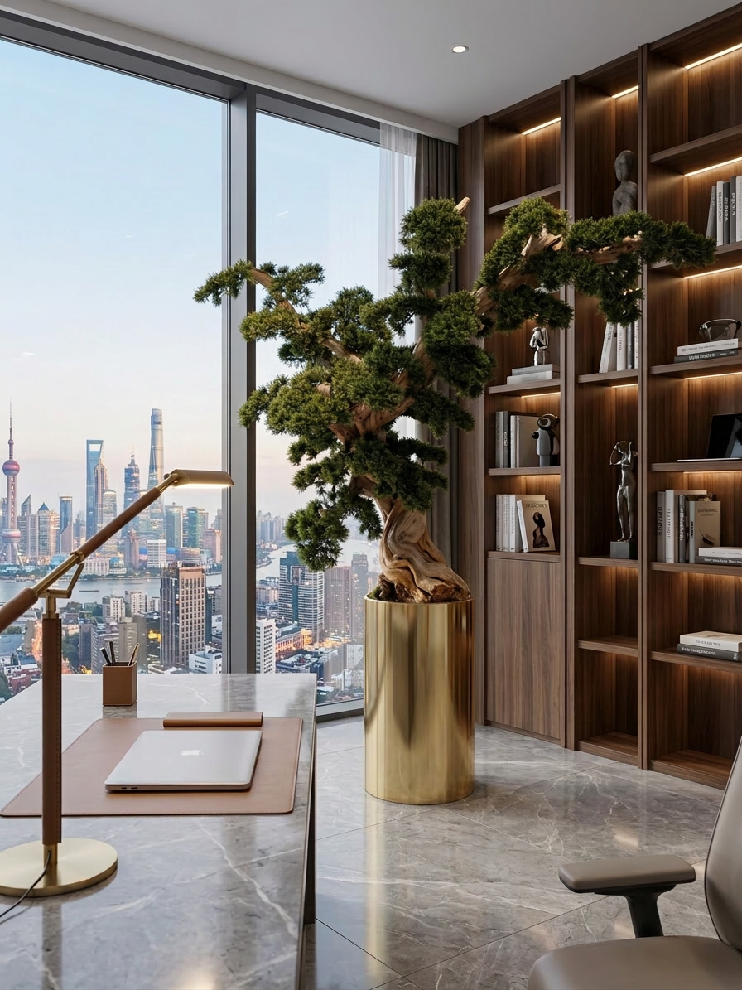

NEW VERSION
Handmade Masterpiece Bonsai Tree with real wood trunk & golden brushed stainless steel 304 pot
Discover a truly exceptional handmade artificial bonsai tree, designed to bring timeless elegance and natural harmony into any interior. Each tree is individually handcrafted, making every piece a unique one-of-one creation. With a real wood trunk, high-quality artificial leaves for a beautifully natural appearance, and a golden brushed stainless steel 304 flower pot, this bonsai combines authentic materials with lasting sophistication.
The result is a refined designer piece that feels both organic and luxurious — ideal for hotels, villas, living rooms, reception areas, lounges, and exclusive interior spaces.
Key Features
- Handmade artificial tree.
- Every bonsai tree is unique and one of a kind (1/1).
- Real wood trunk for authentic texture and natural character.
- Highest quality artificial leaves for a realistic and elegant look.
- Brushed stainless steel 304 flower pot.
- Maintenance-free: no watering – no sun – no care and Hypoallergenic

Specifications size and weight of tree inclusive pot:

SYMBOL : height: Size 200cm-240cm WEIGHT: apx from to…

Wide: 110cm-140cm

Dept: 110cm-140cm

Specifications size of pot only: 47cmx47cm height 82,5cm

General product details
This premium bonsai tree is in a size range of 200 cm to 240 cm. Pictures above shows a sample, every product is unique handmade and can slightly be different through handcrafting and natural growth of the trunk.
The tree is designed for indoor use. While it is generally resistant to sun and moisture, permanent outdoor exposure is not recommended, as long-term hot and cold conditions may affect the materials over time.
Maintenance-free elegance: Enjoy the beauty of this artificial tree all year round, without any ongoing care or seasonal changes – no watering – no sun – no care. Hypoallergenic design: Free from pollen, mold, and seasonal allergens. Perfect for sensitive places and especially well suited for hotels, hospitality spaces and designer homes or offices who want a beautiful green atmosphere all year long without the responsibilities of a living plant.
Pot details stainless steel 304 brushed gold
The extra-large 304 stainless steel flower pot is a distinctive designer element that perfectly complements the tree. Its brushed golden finish gives the product a luxurious and modern appearance, while the stainless steel construction offers durability and resistance to humidity.
Packaging information
The product is delivered in special protective packaging. If the item is supplied in multiple parts, it will need to be assembled by the customer following the included installation instructions.

Red Zen Maple Majesty – Red Velvet - Handmade Masterpiece
Red Maple Tree HANDMADE – Size: 200cm-240cm
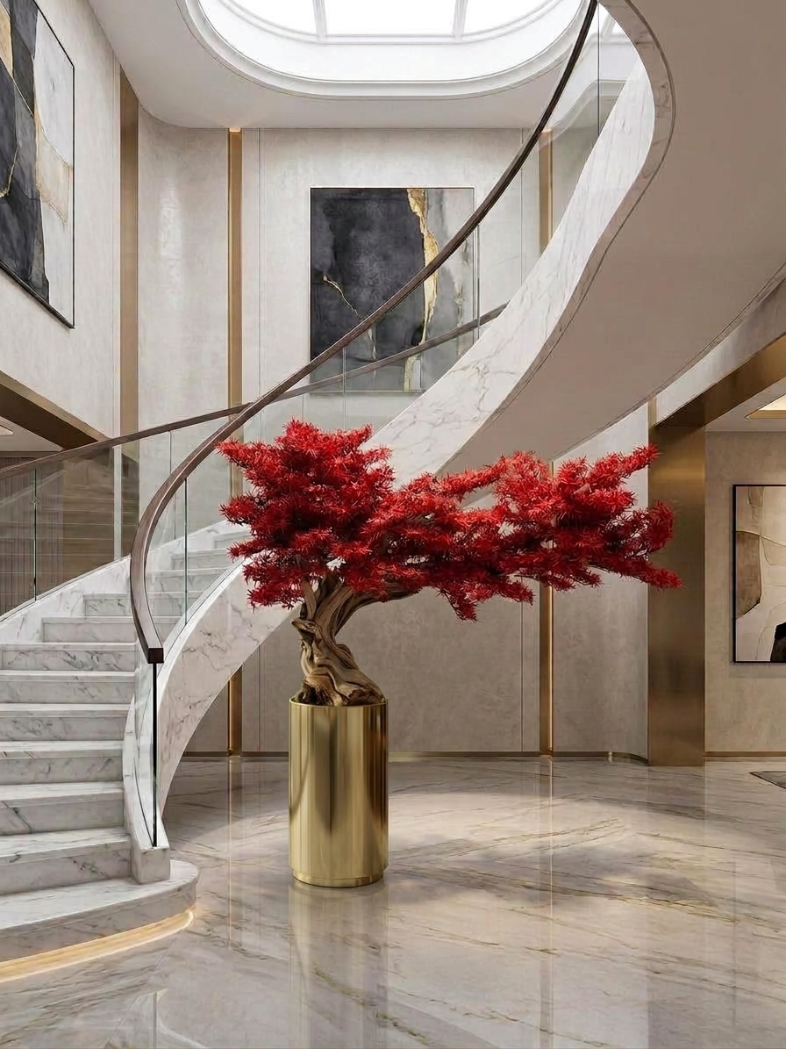

Handmade Masterpiece Red Maple Tree with real wood trunk & golden brushed stainless steel 304 pot
Make a bold statement with this extraordinary artificial handmade maple tree, designed to bring sculptural elegance and modern luxury into any interior. Featuring a beautifully twisted natural wood trunk and vibrant red artificial foliage, it captures the drama of a living centerpiece without requiring any maintenance.
Each tree is individually handcrafted, making every piece a unique one-of-one creation. With a real wood trunk, high-quality artificial leaves for a beautifully natural appearance, and a golden brushed stainless steel 304 flower pot, this bonsai combines authentic materials with lasting sophistication.
The result is a refined designer piece that feels both organic and luxurious — ideal for hotels, villas, living rooms, reception areas, lounges, and exclusive interior spaces.

Key Features
- Handmade artificial tree.
- Every maple tree is unique and one of a kind (1/1).
- Real wood trunk for authentic texture and natural character.
- Highest quality artificial leaves for a realistic and elegant look.
- Brushed stainless steel 304 flower pot.
- Maintenance-free: no watering – no sun – no care and Hypoallergenic

Specifications size and weight of tree inclusive pot:

SYMBOL : height: Size 200cm-240cm WEIGHT: apx from to…

Wide: 110cm-140cm

Dept: 110cm-140cm

Specifications size of pot only: 47cmx47cm height 82,5cm
General product details
This premium maple tree is in a size range of 200 cm to 240 cm height. Pictures above shows a sample, every product is unique handmade and can slightly be different through handcrafting and natural growth of the trunk.
The tree is designed for indoor use. While it is generally resistant to sun and moisture, permanent outdoor exposure is not recommended, as long-term hot and cold conditions may affect the materials over time.
Maintenance-free elegance: Enjoy the beauty of this artificial tree all year round, without any ongoing care or seasonal changes – no watering – no sun – no care. Hypoallergenic design: Free from pollen, mold, and seasonal allergens. Perfect for sensitive places and especially well suited for hotels, hospitality spaces and designer homes or offices who want a beautiful red atmosphere all year long without the responsibilities of a living plant.
Pot details stainless steel 304 brushed gold
The extra-large 304 stainless steel flower pot is a distinctive designer element that perfectly complements the tree. Its brushed golden finish gives the product a luxurious and modern appearance, while the stainless steel construction offers durability and resistance to humidity.
Packaging information
The product is delivered in special protective packaging. If the item is supplied in multiple parts, it will need to be assembled by the customer following the included installation instructions.

Verdant Harmony Tree / Ficus Bonsai Handmade Masterpiece
Zen Ficus Bonsai Tree HANDMADE Size: 200cm-240cm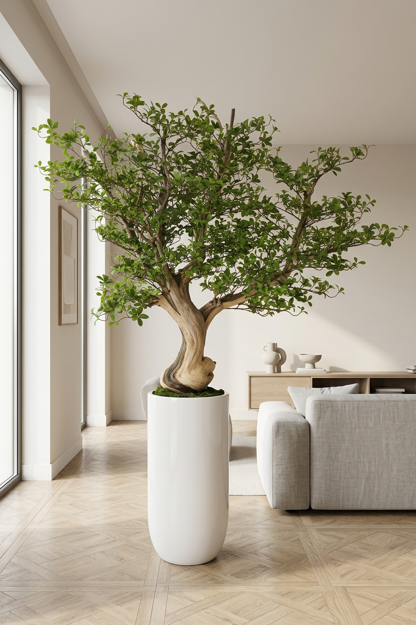
Handmade Masterpiece Ficus Bonsai Tree with real wood trunk and glossy luxury pot
Elevate your interior with this striking artificial Ficus bonsai tree, crafted to bring lush greenery and organic elegance into modern living spaces. Its beautifully twisted natural wood trunk and full canopy of vibrant green leaves create a serene, lifelike presence that feels both timeless and contemporary.
The elegant white or black planter provides a clean, minimalist base, enhancing the tree's sculptural form. This premium piece is perfect for living rooms, offices, lounges, restaurants, hotels and upscale hospitality environments, adding effortless nature to any design.

Key Features
- Handmade artificial tree.
- Every Ficus Bonsai tree is unique and one of a kind (1/1).
- Real wood trunk for authentic texture and natural character.
- Highest quality artificial leaves for a realistic and elegant look.
- black or white glossy luxury pot
- Maintenance-free: no watering – no sun – no care and Hypoallergenic

Specifications size and weight of tree inclusive pot:

SYMBOL : height: Size 200cm-240cm WEIGHT: apx from to…

Wide: 110cm-130cm

Dept: 110cm-130cm

Specifications size of pot only: 40cmx40cm height 80cm
General product details
This premium Ficus Bonsai Tree is in a size range of 200 cm to 240 cm. Pictures above shows a sample, every product is unique handmade and can slightly be different through handcrafting and natural growth of the trunk.
The tree is designed for indoor use. While it is generally resistant to sun and moisture, permanent outdoor exposure is not recommended, as long-term hot and cold conditions may affect the materials over time.
Maintenance-free elegance: Enjoy the beauty of this artificial tree all year round, without any ongoing care or seasonal changes – no watering – no sun – no care. Hypoallergenic design: Free from pollen, mold, and seasonal allergens. Perfect for sensitive places and especially well suited for hotels, hospitality spaces and designer homes or offices who want a beautiful green atmosphere all year long without the responsibilities of a living plant.
Pot details (black or white):
High-quality luxury glossy black or white tree pot. It offers excellent stability and a glossy finish, it is perfect for showcasing trees and flowers while adding a luxury touch to your decor. To keep the pot shiny it should be placed only inside and it is not recommended to place in wet areas.
Packaging information
The product is delivered in special protective packaging. If the item is supplied in multiple parts, it will need to be assembled by the customer following the included installation instructions.

White Bloom Majesty / Snow Blossom Cherry – Handmade unique
Snow Cherry Blossom Tree WHITE HANDMADE size: 200cm-240cm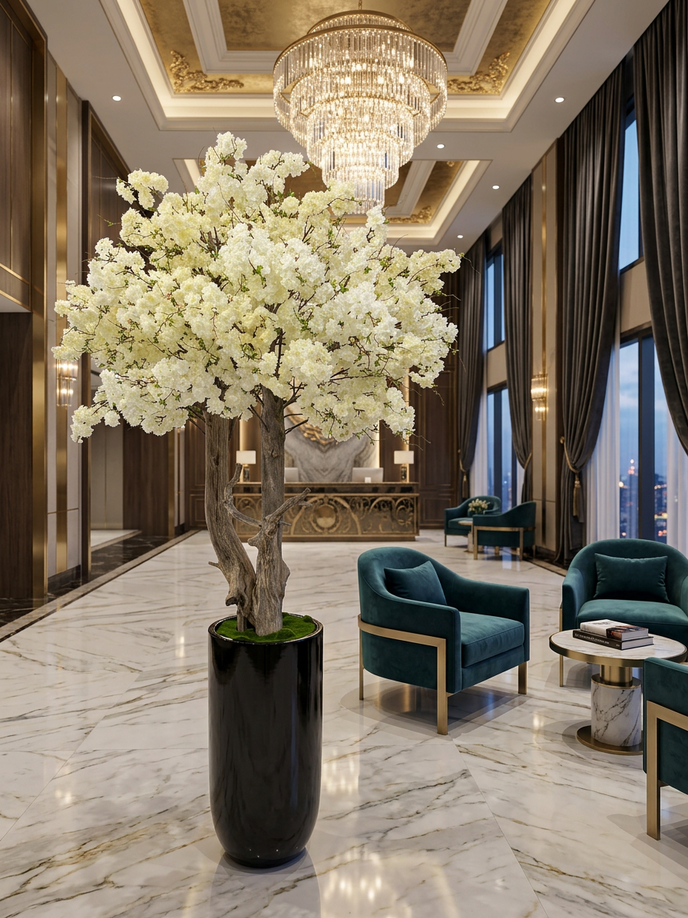

Handmade Masterpiece Snow Cherry Blossom Tree white with real wood trunk & glossy luxury pot
Bring timeless elegance into your interior with this stunning artificial flowering tree, designed to create a refined and natural atmosphere in any luxury space. With its detailed natural wood trunk and full canopy of soft white blossoms, it delivers the beauty of a blooming tree without any seasonal limits or maintenance.
The sleek black or white planter adds a modern contrast, making this piece feel both contemporary and sophisticated. Its tall silhouette and airy floral crown make it an ideal decorative feature for entrance areas, living spaces, hotels, boutiques, and high-end commercial interiors.

Key Features
- Handmade artificial tree.
- Every tree is unique and one of a kind (1/1).
- Real wood trunk for authentic texture and natural character.
- Highest quality artificial leaves for a realistic and elegant look.
- black or white glossy luxury pot
- Maintenance-free: no watering – no sun – no care and Hypoallergenic

Specifications size and weight of tree inclusive pot:

SYMBOL : height: Size 200cm-240cm WEIGHT: apx from to…

Wide: 110cm-130cm

Dept: 110cm-130cm

Specifications size of pot only: 40cmx40cm height 80cm
General product details
This premium Cherry Blossom tree white is in a size range of 200 cm to 240 cm height. Pictures above shows a sample, every product is unique handmade and can slightly be different through handcrafting and natural growth of the trunk.
The tree is designed for indoor use. While it is generally resistant to sun and moisture, permanent outdoor exposure is not recommended, as long-term hot and cold conditions may affect the materials over time.
Maintenance-free elegance: Enjoy the beauty of this artificial tree all year round, without any ongoing care or seasonal changes – no watering – no sun – no care. Hypoallergenic design: Free from pollen, mold, and seasonal allergens. Perfect for sensitive places and especially well suited for hotels, hospitality spaces and designer homes or offices who want a beautiful white atmosphere all year long without the responsibilities of a living plant.
Pot details (black or white):
High-quality luxury glossy black or white tree pot. It offers excellent stability and a glossy finish, it is perfect for showcasing trees and flowers while adding a luxury touch to your decor. To keep the pot shiny it should be placed only inside and it is not recommended to place in wet areas.
Packaging information
The product is delivered in special protective packaging. If the item is supplied in multiple parts, it will need to be assembled by the customer following the included installation instructions.

Dual Pink Sakura Tree – Cherry Blossom Handmade unique
Cherry Blossom Tree DAUL PINK – HANDMADE 200cm-240cm
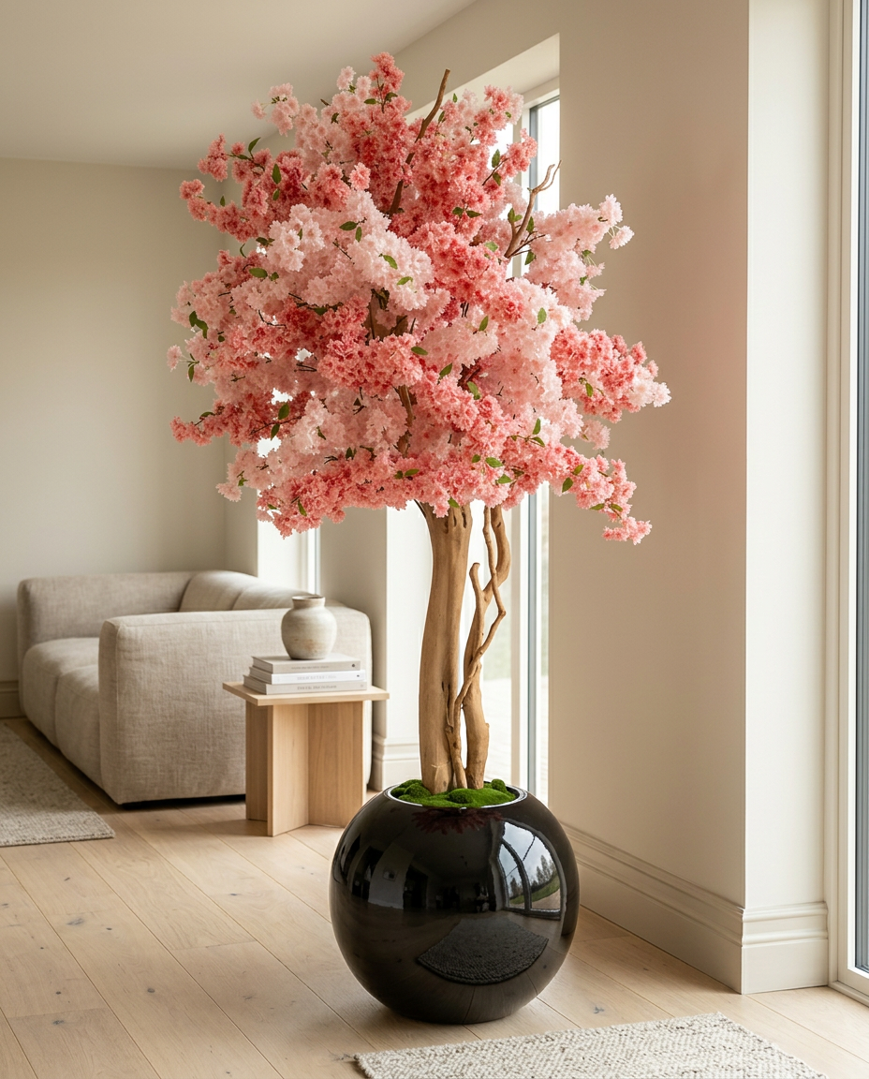

Handmade Cherry Blossom Tree dual-pink with real wood trunk and glossy XL luxury pot

Bring a soft, romantic touch to your space with this elegant artificial cherry blossom tree pink, designed to capture the delicate beauty of spring all year round. Its full pink blossom canopy and natural wood trunk create a graceful, lifelike look that adds warmth and sophistication to any interior.
The glossy black or white planter gives the piece a modern, luxurious finish, while the sculptural shape of the tree makes it a true statement element for living rooms, bedrooms, lounges, boutiques, and refined hospitality spaces. It delivers lasting beauty without any maintenance, making it ideal for stylish interiors that deserve a calm and polished atmosphere.

Key Features
- Handmade artificial tree.
- Every Cherry Blossom tree pink is unique and one of a kind (1/1).
- Real wood trunk for authentic texture and natural character.
- Highest quality artificial leaves for a realistic and elegant look.
- black or white glossy luxury pot
- Maintenance-free: no watering – no sun – no care and Hypoallergenic

Specifications size and weight of tree inclusive pot:

SYMBOL : height: Size 200cm-240cm WEIGHT: apx from to…

Wide: 110cm-130cm

Dept: 110cm-130cm

Specifications size of pot only: 66x66cm height 55cm
General product details
This premium Cherry Blossom tree pink is in a size range of 200 cm to 240 cm. Pictures above shows a sample, every product is unique handmade and can slightly be different through handcrafting and natural growth of the trunk.
The tree is designed for indoor use. While it is generally resistant to sun and moisture, permanent outdoor exposure is not recommended, as long-term hot and cold conditions may affect the materials over time.
Maintenance-free elegance: Enjoy the beauty of this artificial tree all year round, without any ongoing care or seasonal changes – no watering – no sun – no care. Hypoallergenic design: Free from pollen, mold, and seasonal allergens. Perfect for sensitive places and especially well suited for hotels, hospitality spaces and designer homes or offices who want a beautiful pink atmosphere all year long without the responsibilities of a living plant.
Pot details (black or white):
High-quality XL luxury glossy black or white tree pot. It offers excellent stability and a glossy finish, it is perfect for showcasing trees and flowers while adding a luxury touch to your decor. To keep the pot shiny it should be placed only inside and it is not recommended to place in wet areas. .
Packaging information
The product is delivered in special protective packaging. If the item is supplied in multiple parts, it will need to be assembled by the customer following the included installation instructions.

Paradise Leaf Giant – Handmade – Tropical Strelitzia Majesty
Tropical Strelitzia Giant HANDMADE Size: 200cm-240cm
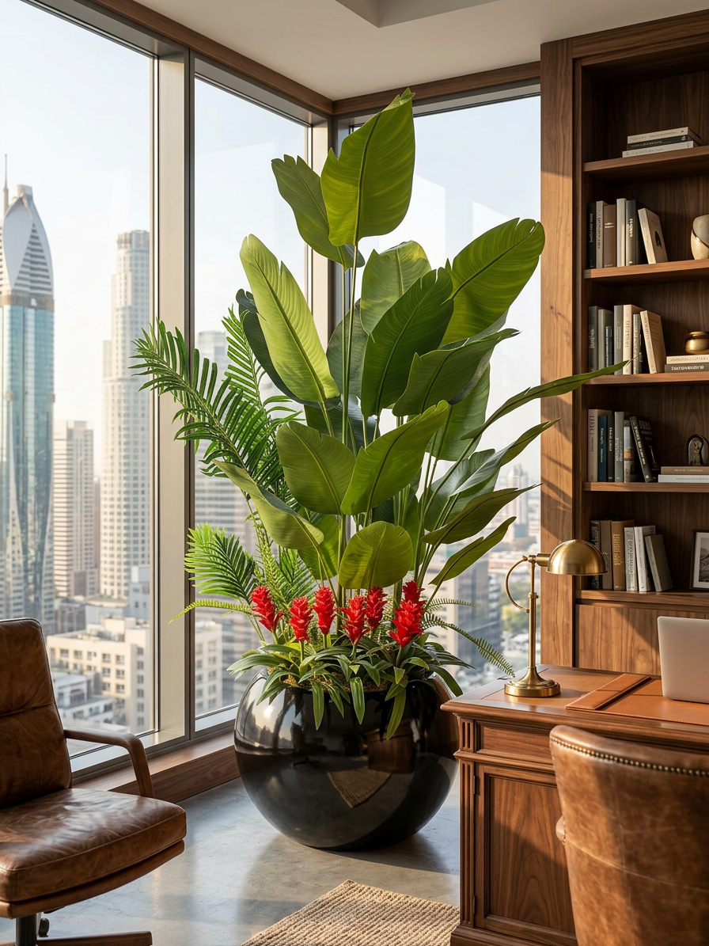

Handmade Tropical Strelitzia with glossy XL luxury pot
Transform your office or living space with this vibrant artificial bird of paradise tree, blending tropical allure with sophisticated design. Its large, lush green leaves and striking red ginger flowers create a bold, exotic statement, paired with a natural authentic texture.
The glossy black planter adds a sleek, contemporary edge, making it the ultimate centerpiece for modern interiors. Perfect for executive offices, luxury apartments, hotel lobbies, restaurants, and high-end commercial settings with stunning city views.
Key Features
- Handmade artificial plant.
- authentic texture and natural character.
- Highest quality artificial leaves for a realistic and elegant look.
- Shiny black acrylic flower pot.
- Maintenance-free: no watering – no sun – no care and Hypoallergenic

Specifications size and weight of tree inclusive pot:

SYMBOL : height: Size 220cm-250cm WEIGHT: apx from to…

Wide: 100cm-120cm

Dept: 100cm-120cm

Specifications size of pot only: 80cmx80cm height 60cm
General product details
This premium Tropical Strelitzia is in a size range of 220 cm to 250 cm. Pictures above shows a sample, every product is unique handmade and can slightly be different through handcrafting.
The plant is designed for indoor use. While it is generally resistant to sun and moisture, permanent outdoor exposure is not recommended, as long-term hot and cold conditions may affect the materials over time.
Maintenance-free elegance: Enjoy the beauty of this artificial plant all year round, without any ongoing care or seasonal changes – no watering – no sun – no care. Hypoallergenic design: Free from pollen, mold, and seasonal allergens. Perfect for sensitive places and especially well suited for hotels, hospitality spaces and designer homes or offices who want a beautiful green atmosphere all year long without the responsibilities of a living plant.
Pot details (black or white):
High-quality XL luxury glossy black or white plant pot. It offers excellent stability and a glossy finish, it is perfect for showcasing trees and flowers while adding a luxury touch to your decor. To keep the pot shiny it should be placed only inside and it is not recommended to place in wet areas. .
Packaging information
The product is delivered in special protective packaging. If the item is supplied in multiple parts, it will need to be assembled by the customer following the included installation instructions.

Orchid Cascade Grande – Handmade – Orchid Grande Majestic orange

Orchid Grande MAJESTIC ORANGE size: 190cm-200cm

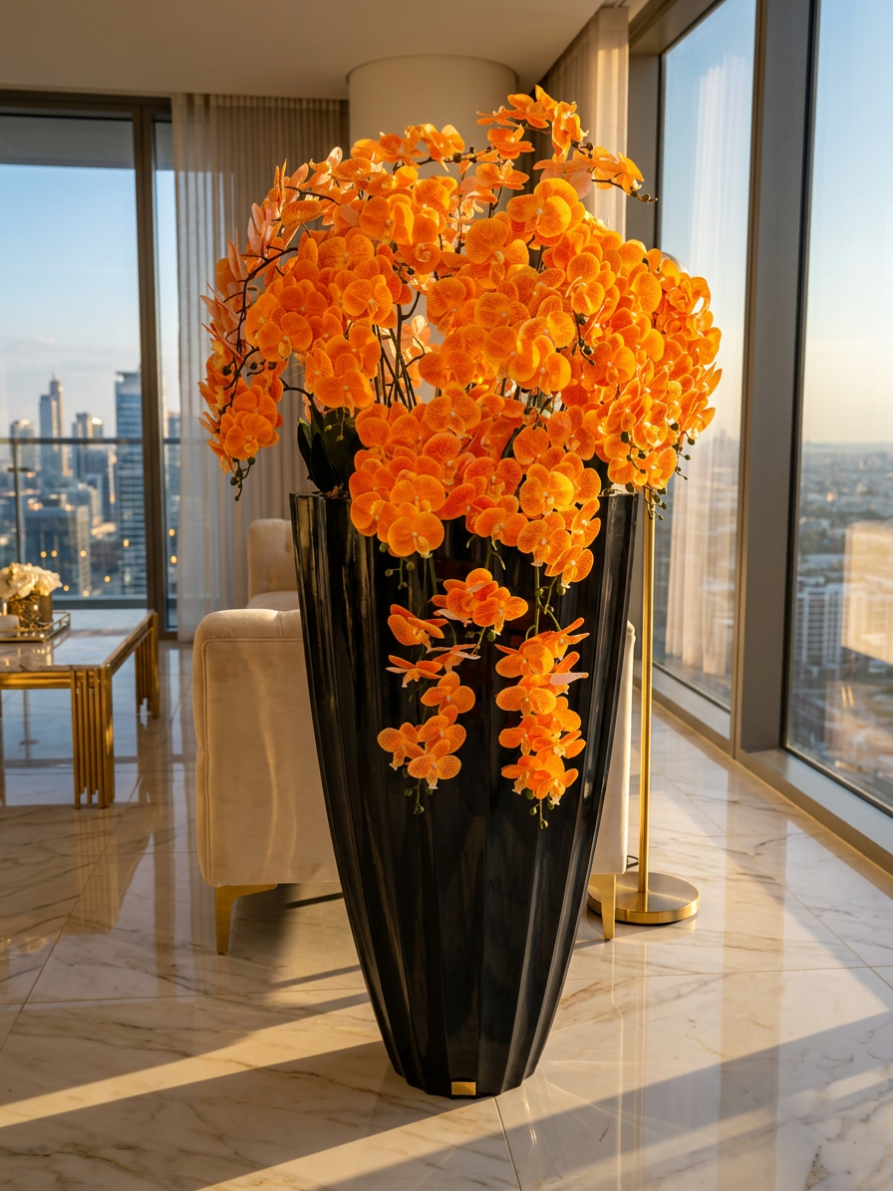

Handmade Orchid MAJESTIC ORANGE with oversized black glossy luxury pot Infuse your space with vibrant luxury using this breathtaking artificial orchid arrangement, designed to command attention with its bold color and elegant form. Cascading clusters of vivid orchids create a tropical paradise vibe, perfect for elevating high-rise interiors or sophisticated settings.
The tall black planter offers a high luxury contrast and modern polish, making this piece a true showstopper. Ideal for penthouse living rooms, luxury hotels, upscale offices, luxury boutiques, designer homes or elegant restaurants.
Key Features
- Handmade artificial flower plant.
- Different colors
- authentic texture and natural character.
- Highest quality artificial leaves and flowers for a realistic and natural look.
- Shiny black acrylic flower pot.
- Maintenance-free: no watering – no sun – no care and Hypoallergenic

Specifications size and weight of tree inclusive pot:

SYMBOL : height: Size 190cm-200cm WEIGHT: apx from to…

Wide: 80cm-100cm

Dept: : 80cm-100cm

Specifications size of pot only: 72cmx72cm height 127cm
General product details
This premium Orchid Cascade Grande is in a size range of 190 cm to 200 cm. Pictures above shows a sample, every product is unique handmade and can slightly be different through handcrafting.
The plant is designed for indoor use. While it is generally resistant to sun and moisture, permanent outdoor exposure is not recommended, as long-term hot and cold conditions may affect the materials over time.
Maintenance-free elegance: Enjoy the beauty of this artificial plant all year round, without any ongoing care or seasonal changes – no watering – no sun – no care. Hypoallergenic design: Free from pollen, mold, and seasonal allergens. Perfect for sensitive places and especially well suited for hotels, hospitality spaces and designer homes or offices who want a beautiful flower atmosphere all year long without the responsibilities of a living plant.
Pot details (black or white):
High-quality oversized luxury glossy black tree pot. It offers excellent stability and a glossy finish, it is perfect for showcasing trees and flowers while adding a luxury touch to your decor. To keep the pot shiny it should be placed only inside and it is not recommended to place in wet areas. .
Packaging information
The product is delivered in special protective packaging. If the item is supplied in multiple parts, it will need to be assembled by the customer following the included installation instructions.

Flora Prestige – Rose Royale – Handmade
Rose Royale – PURPLE – HANDMADE SIZE: 110cm-130cm
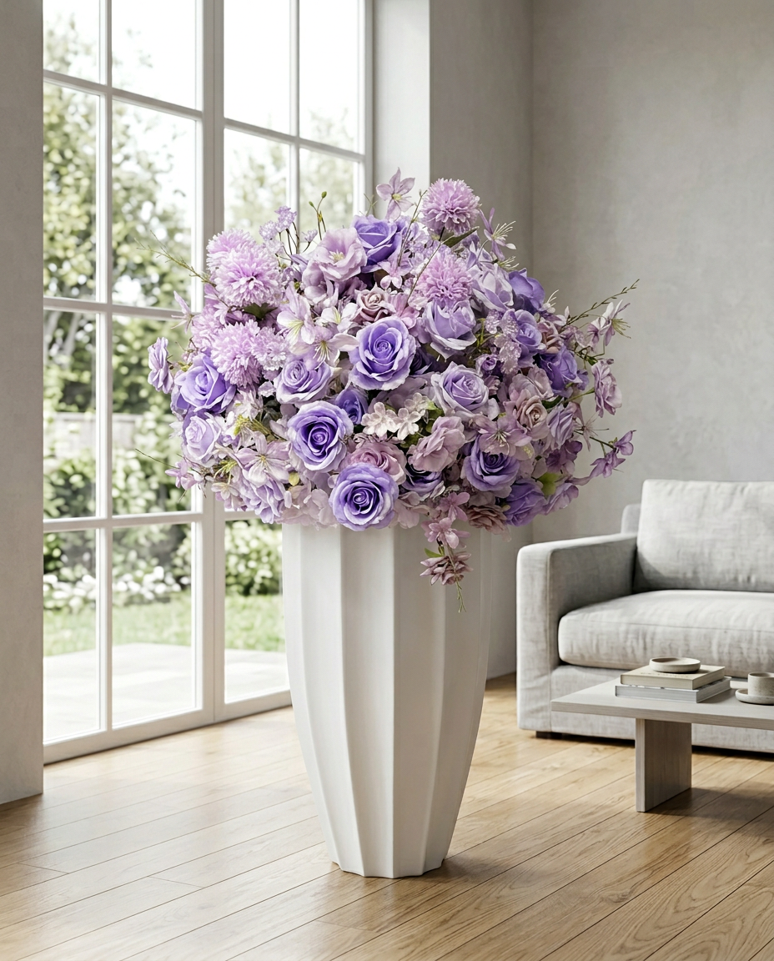

Handmade Rose Royale with luxury white glossy or white golden luxury pot
Introduce a touch of romantic elegance with this luxurious artificial flower arrangement, featuring a stunning mix of roses, hydrangeas, orchids and delicate flowers for a full, opulent bouquet. The soft tones and lush blooms create a dreamy, feminine vibe that's both timeless and refined.
The tall white planter adds a clean, architectural base, making it a perfect focal point for contemporary interiors. Ideal for living rooms, bedrooms, events, weddings, entrances, boutiques, salons, and high-end hospitality spaces.

Key Features
- Handmade artificial plant.
- Different colors
- authentic texture and natural character.
- Highest quality artificial leaves and flowers for a realistic and elegant look.
- Luxury glossy white or golden white pot
- Maintenance-free: no watering – no sun – no care and Hypoallergenic

Specifications size and weight of tree inclusive pot:

SYMBOL : height: Size 110cm-130cm WEIGHT: apx from to…

Wide: 70cm-80cm

Dept: 70cm-80cm

Specifications size of pot 40cmx40cm height 80cm
General product details
This premium Rose Royale is in a size range of 70 cm to 80 cm. Pictures above shows a sample, every product is unique handmade and can slightly be different through handcrafting.
The plant is designed for indoor use. While it is generally resistant to sun and moisture, permanent outdoor exposure is not recommended, as long-term hot and cold conditions may affect the materials over time.
Maintenance-free elegance: Enjoy the beauty of this artificial plant all year round, without any ongoing care or seasonal changes – no watering – no sun – no care. Hypoallergenic design: Free from pollen, mold, and seasonal allergens. Perfect for sensitive places and especially well suited for hotels, hospitality spaces and designer homes or offices who want a beautiful flower atmosphere all year long without the responsibilities of a living plant.
Pot details (white/golden white):
High-quality luxury glossy white or golden white pot. It is perfect for showcasing this flowers while adding a luxury touch to your decor. To keep the pot shiny it should be placed only inside and it is not recommended to place in wet areas.
Packaging information
The product is delivered in special protective packaging. If the item is supplied in multiple parts, it will need to be assembled by the customer following the included installation instructions.

Zen Magnolia Bloom – Pink Magnolia Art (Grace) (Handmade - Table flower)
ZEN Magnolia PINK HANDMADE size 50cm-70cm
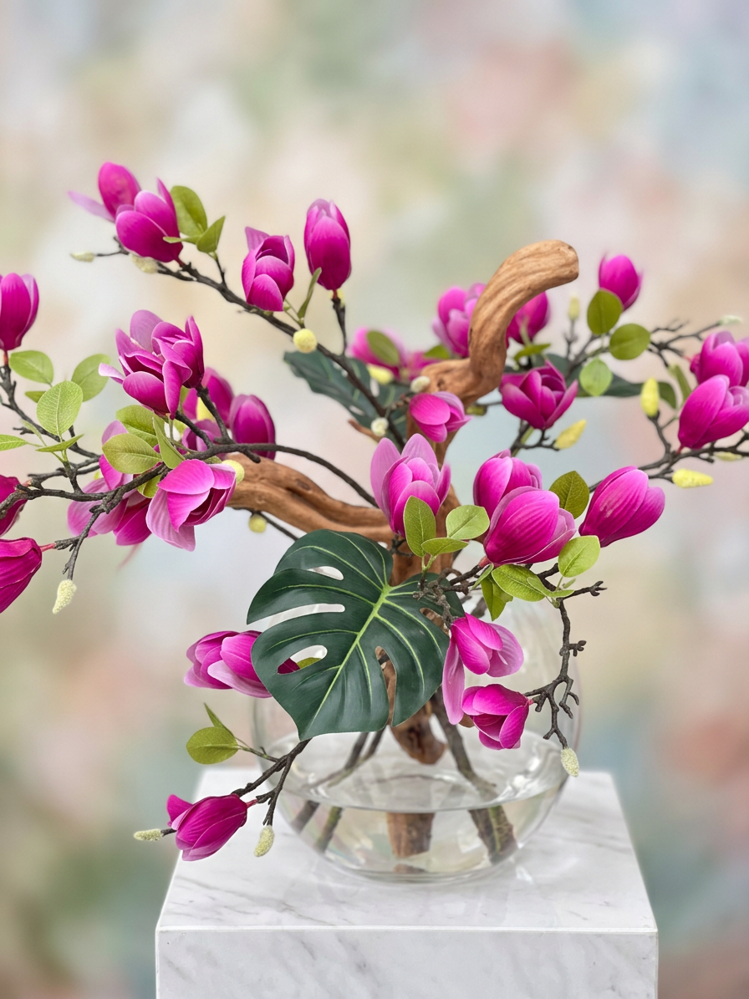

Zen Magnolia PINK HANDMADE with elegant glass pot
Add a burst of exotic romance with this exquisite artificial magnolia branch arrangement, showcasing vibrant pink magnolia buds, fresh green leaves, and a striking monstera leaf for beautiful texture. The natural wood branch adds an organic, sculptural element, evoking springtime luxury in a compact design.
Presented in a clear glass vase, it offers a fresh, water-like illusion that enhances its lifelike appeal. Perfect for tabletops, consoles, dining areas, bathrooms, boutiques and premium interior styling.
Key Features
- Handmade artificial plant
- Real wood for authentic texture and natural character.
- Highest quality artificial leaves and flowers for a realistic and elegant look.
- Elegant glas flower pot.
- Maintenance-free: no watering – no sun – no care and Hypoallergenic

Specifications size and weight of tree inclusive pot:

SYMBOL : height: Size 50cm-70cm WEIGHT: apx from to…

Wide: 50cm-70cm

Dept: 50cm-70cm

Specifications size of pot 30cmx30cm height 30cm
General product details
This premium Zen Magnolia Bloom is in a size range of 50 cm to 70 cm. Pictures above shows a sample, every product is unique handmade and can slightly be different through handcrafting.
The plant is designed for indoor use. While it is generally resistant to sun and moisture, permanent outdoor exposure is not recommended, as long-term hot and cold conditions may affect the materials over time.
Maintenance-free elegance: Enjoy the beauty of this artificial plant all year round, without any ongoing care or seasonal changes – no watering – no sun – no care. Hypoallergenic design: Free from pollen, mold, and seasonal allergens. Perfect for sensitive places and especially well suited for hotels, hospitality spaces and designer homes or offices who want a beautiful flower atmosphere all year long without the responsibilities of a living plant.
Pot details:
Glass flower pot with an elegant and timeless design. Crafted from premium, durable glass, it offers a clear, refined look that beautifully highlights plants and flowers. Its smooth finish and sturdy construction make it a stylish addition to any indoor space, adding a touch of sophistication to your décor.
Packaging information
The product is delivered in special protective packaging. If the item is supplied in multiple parts.

